Are the following statements right or wrong?
- In road construction, dense asphalt is more sound absorptive than porous asphalt.
- Propagation-based abatement is the best way to address noise problems.
- Auto-transmission produces less noise compared to manual transmission in vehicles.
- The primary objective of rail grinding is to improve the acoustic absorption of the tracks.
- The most commonly used method for mitigating noise from railway source is to improve the rolling stock (breaks and wheels).
- Geometry and orientation of buildings are the most important factors building designers should keep in mind when it comes to noise abatement measures.
- The height of a noise barrier plays an important role in the effectiveness of the barrier.
- Noise barriers are most effective when the barrier is of the same height throughout its length.
- Noise barriers could afford to have breaks in them if there is sufficient overlaps between two adjacent sections.
- Buildings a) and b) have different roof shapes; b) is more effective for noise reduction than a).
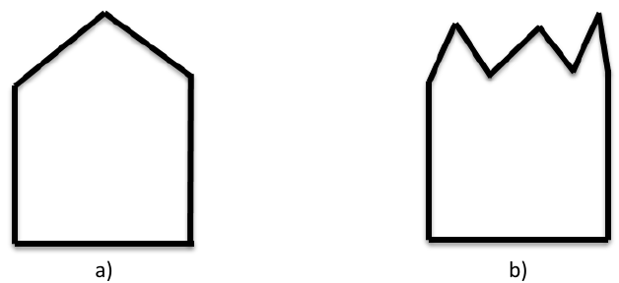

- The reduction of noise through the ground effects is only through absorption.
- Noise barriers that don’t block the line of sight between the source and the receiver are useful in terms of noise reduction.
- Green treatments on buildings (e.g., green facades, courtyards or terraces) are more effective for noise abatement than closely-packed trees on a street.
- Noise barriers are most effective closer to the source than at a distance from the source, or near the receiver.
- The effect of the ground on noise abatement is also caused by diffraction.

